**Data structure Lab assignment 1**

1. Write c program to Increment & Decrement Operations Using Pointer

Code:

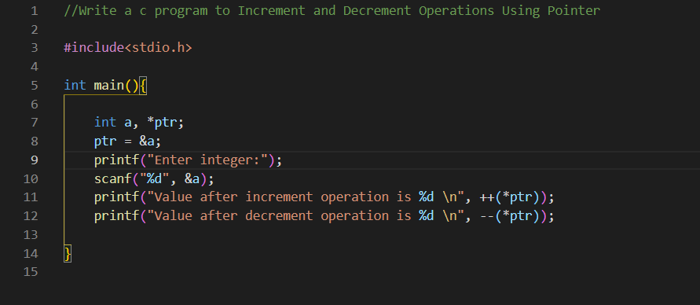

Output:

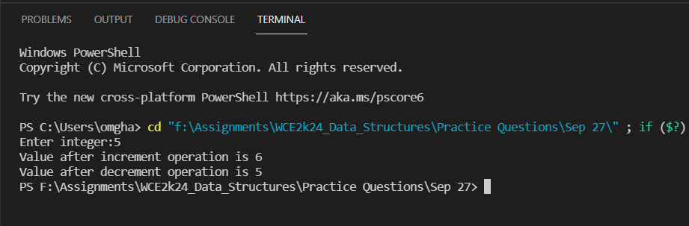

1. Write a C program to find the length of the string Using Pointer

Code:

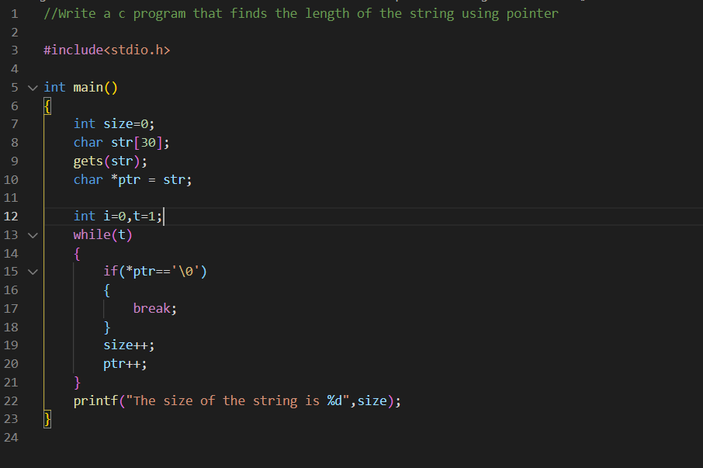

Output:

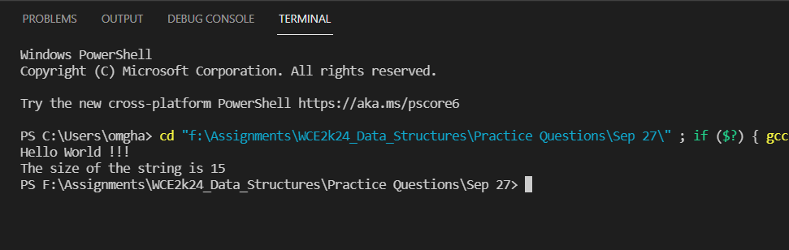

1. Add Two Numbers using pointers

Code:

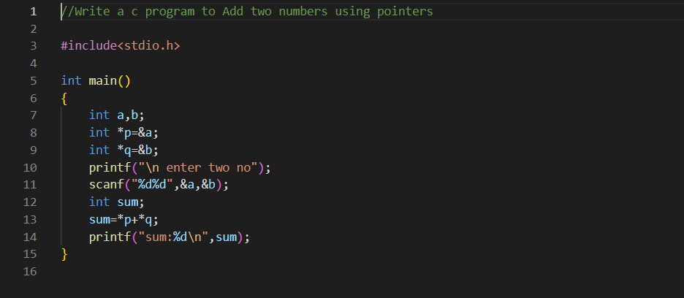

Output:

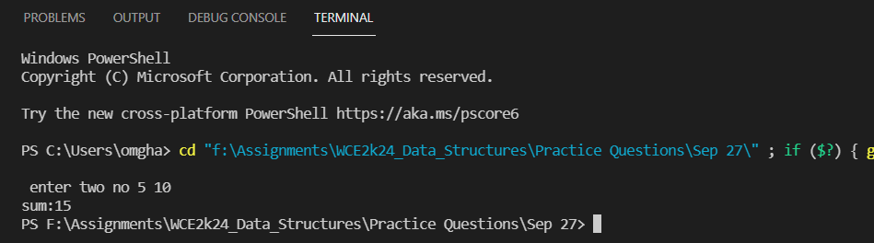

1. Write c program to reverse Array Using Pointers

Code:

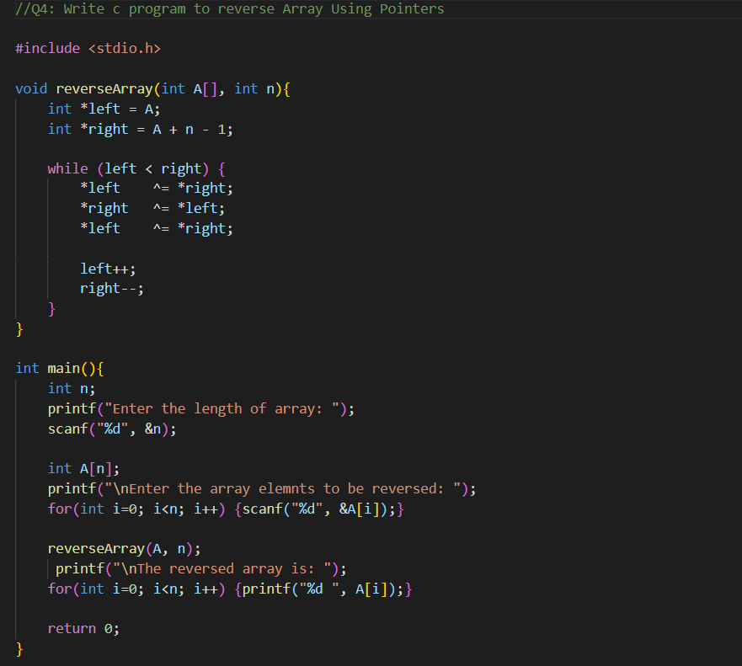

Output:

